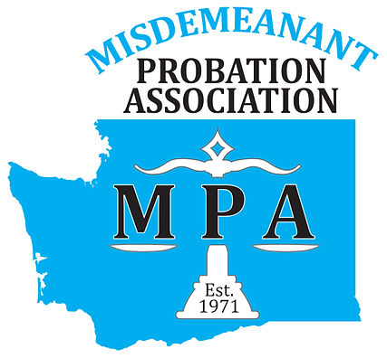
MPA Award Nomination Consideration
Please send completed form to cng@bellevuea.gov by March 24th, 2025
Submitted By: ______________________________
Contact Information: _______________________________
I Nominate: _______________________________
For: _____________________________________________ (ex. Probation Officer of the Year)

Three Brief Reasons Why (bullet points):

